Algebra II/ Trig Name____________________________
Chapter 8 (2012a) Block___________________
NO Calculator

1) Graph the function.
Plot 3 points. Draw asymptote on the graph.

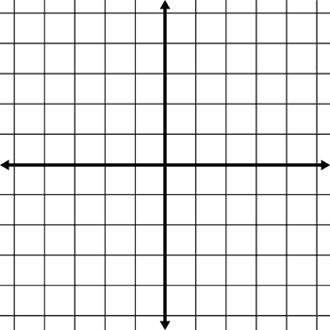
Asymptote Equation ______________
Domain = _______________________
Range = ________________________

2) Write in exponential form:
___________________________
3) Write in logarithmic form:
___________________________

4) Graph the function.
Plot 3 points. Draw asymptote on the graph.

Asymptote Equation ______________
Domain = _______________________
Range = ________________________

5) Expand the expression:
a)
_____________________________________________
6) Condense the expressions:
a)
_____________________________________________

7) Evaluate the expression if possible:
a) = __________________

b) = __________________

c) = __________________

d) = ___________________

e) = __________________

f) = ____________________

g) = __________________

8) If a Ford Expedition has a depreciation equation of
and a
Chevy Tahoe has a depreciation equation of
…
Which car would be more financially responsible to buy? Explain.

Solve for x (9) – (12); Show all your work.
9) 5^{x} - 1 = 24

10)

11)

12)

Find the inverse of the following.
13)

14)

15) Consider the exponential growth function:
. Describe the transformation from this function if the following changes occur.
a) “a” changes to -1 __________________________________________________________________________________________
b) “b” changes to
__________________________________________________________________________________________
c) the exponent changes to x-3
__________________________________________________________________________________________
d) “k” changes to -1
__________________________________________________________________________________________

16) Describe the relationship between the graph of
and

17) Explain in detail : what is an asymptote?
______________________________________________________________________________
18) Explain in detail where do asymptotes come from?
______________________________________________________________________________

19) Graph the following .
Plot 3 points.

20) The graph of which function is shown.
(A)
(B)
(C )
(D)
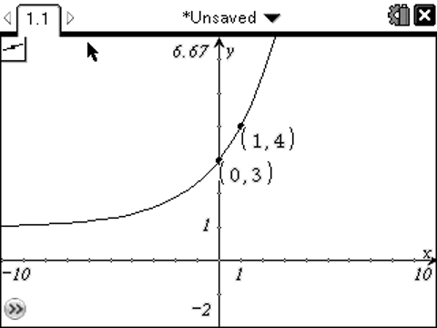

CALCULATOR Formulas

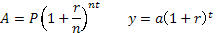
1) $15,000 is deposited in an account that pays 5.75% annual interest. Which would be the better option? Compounding Continuously or Compounding Quarterly.

2) Mr. Degitz wants to retire with $1million. How much should be deposited at 4.5% compounded monthly to achieve his goal? He will work for 30 years.

3) Find the time needed to triple a $2000 investment compounded continuously at 12%.

4) The value of a new $23,000 car purchased in 2000 decreased by 13% per year. Find the value of the car in 2004 to the nearest cent.

5) The yearly cost for residents to attend a local state university has increased from $5200 to $9000 in the last 5 years.
a.) What is the percent increase in tuition costs to the nearest tenth of a percent?

b.) If this increase continues, what will the cost be in 5 more years?
6) One hundred grams of radium are stored in a container. The amount R(in grams) of radium present after t years can be modeled by . After how many years will only 5 grams of radium be present?

7) Is investing $3000 at 6% annual interest and $3000 at 8% annual interest equivalent to investing $6000 (the total of two principals) at 7% annual interest (the average of the two interest rates)? Explain which option would be better.

8) Solve for x: Round to thousandths.

a) 2^{x} = 15

b) 5^{2x-3} +4 = 21

c)

d)

